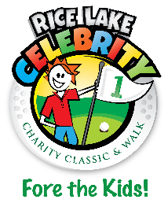
Rice Lake Celebrity Charity Classic
2022 Grant Application

RLCCC Grant Awards are for Rice Lake Area non-profit/not-for-profit organizations that provide services to Rice Lake area youth.* Applications for this year will be accepted from September 16, until the deadline of Friday, September 30, 2022. Applications will be reviewed by the RLCCC Board with recommendations to be determined by October 7.** Disbursements of grants will be awarded at Turtleback on a tentative date of Wednesday, October 26. Please tentatively save that date as you submit your application.

Date of Application:
Name of Organization – Legal name if different:
Employer Identification Number (EIN):
Address of Organization:
Contact Information Name:
Title:
Phone:
Email:
Description of Organization:
Number of youth served in the Rice Lake area annually:
Brief Description of Project/ Needs of Organization / How Grant Money Will Be Used:
Amount of Request:
Has Your Club Helped or Can Your Club Help With Any RLCCC Events? If So, In What Capacity?

*Please note that your organizations application for a RLCCC Grant does not in any way guarantee your organization will receive any funds from the RLCCC.
**Upon notification of grant approval for your organization, you will be required to produce proof of tax ID# before receiving grant monies. Failure to provide tax ID# information will make your application null and void.

Send Application to: RLCCC, PO Box 344, Rice Lake, WI 54868 or info@rlccc4thekids.com
Questions? Please contact Steve Tangwall at 715-736-4705 or stangwall@johnsonfinancialgroup.com

