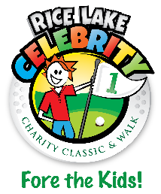
Rice Lake Celebrity Charity Classic
2018 Grant Application

RLCCC Grant Awards are for Rice Lake Area non-profit/not-for-profit organizations that provide services to Rice Lake area youth.*
Applications for the year will be accepted from October 1, 2018, until the deadline of October 12th, 2018. Applications will be reviewed by the RLCCC Board with recommendations to be voted on or prior to October 26th.**
Disbursements of grants will be presented on Wednesday, November 14th at Turtleback.

Date of Application: | Click here to enter a date.
Name of Organization – Legal name if different: | Click here to enter text.
Employer Identification Number (EIN): | Click here to enter text.
Address of Organization: | Click here to enter text.
Contact Information Name:  Title:  Phone:  Email: | Click here to enter text.
Description of Organization: | Click here to enter text.
Number of youth served in the Rice Lake area annually: | Click here to enter text.
Brief Description of Project/ Needs of Organization / How Grant Money Will Be Used: | Click here to enter text.
Amount of Request: | Click here to enter text.
Has Your Club Helped or Can Your Club Help With Any RLCCC Events? If So, In What Capacity? | Click here to enter text.
*Please note that your organizations application for a RLCCC Grant does not in any way guarantee your organization will receive any funds from the RLCCC.
**Upon notification of grant approval for your organization, you will be required to produce proof of tax ID# before receiving grant monies. Failure to provide tax ID# information will make your application null and void.

Send Application to: RLCCC, PO Box 344, Rice Lake, WI 54868 or info@rlccc4thekids.com
Questions? Please contact Steve Tangwall at 715-736-4705 or stangwall@johnsonbank.com

